CTEC601 2024 S2

Assignment 1 – Rube Goldberg Machine

# Name of the Machine: Duck vs Toaster

Screen Recording Link: <https://www.youtube.com/watch?v=aMcBvBdSPTU>

# Team Members

|  |  |  |  |
| --- | --- | --- | --- |
| Name | Contribution description | Contribution weight | Signature |
| Ishanika Singh | Section 1, Design + Assets | 33.3% | Ishanika |
| Abby Sutton | Section 2 Design + Assets | 33.3% | Abby |
| Liliana Nicolo | Section 3 Design + Assets | 33.3% | Liliana |

# Description

Roughly describe the machine:

* *What is its basic functionality (e.g., Coke Bottle Dispenser)?*

The objective is to get the balls (the bath bombs) to reach with one another to push the duck off the shelf so that it falls into the soap box and subsequently into the bathtub resulting in an explosion. The primary objective of our machine is to get a duck and a toaster into the bathtub, causing a dramatic explosion. Each component of the machine has been carefully planned and positioned to ensure that the sequence unfolds smoothly, leading up to the final moment. We carefully crafted our own assets to fit the bathroom theme e.g. combs, soap box, bathtub, sink, duck etc. We created anything extra that we wanted to add such as the toaster.

* *Roughly, how many components/parts does it consist of?*

The project is divided into three main parts: the beginning, middle, and end. Each group member was assigned a specific section to work on independently, and we then combined our efforts to complete the project. In the first section, we focused on utilizing the ground in the bathroom by weaving the ball towards ground level and exploring different levels. The second section introduces more complex triggers and serves as a transition between the first and final sections. It is fast paced and utilizes various triggers to have more precise timing. The last section centres on the goal, involving the interaction between the bath bomb and the duck. It then releases the duck into the bathtub and launching the toaster, resulting in the explosion we wanted to achieve. We have 24 parts/components in total :)

* *What is the average runtime?*

The machine runs for approximately 1 minute and 40 seconds.

* *What sort of physically simulated “features” have you used, e.g., Ball Joint, Domino Effect, Levers, Motors,*

We have used a variety of physically simulated features; examples are listed below:

* Hinge Joint (for soap box)
* Domino Effect
* Levels
* Particle Effect (explosion)
* Fixed Joints
* Triggers
* Collisions
* Materials – Bouncy & Ice
* Constant Force

# Sketches/Screenshots

Insert some key sketches or screenshots of the machine (max. two pages)

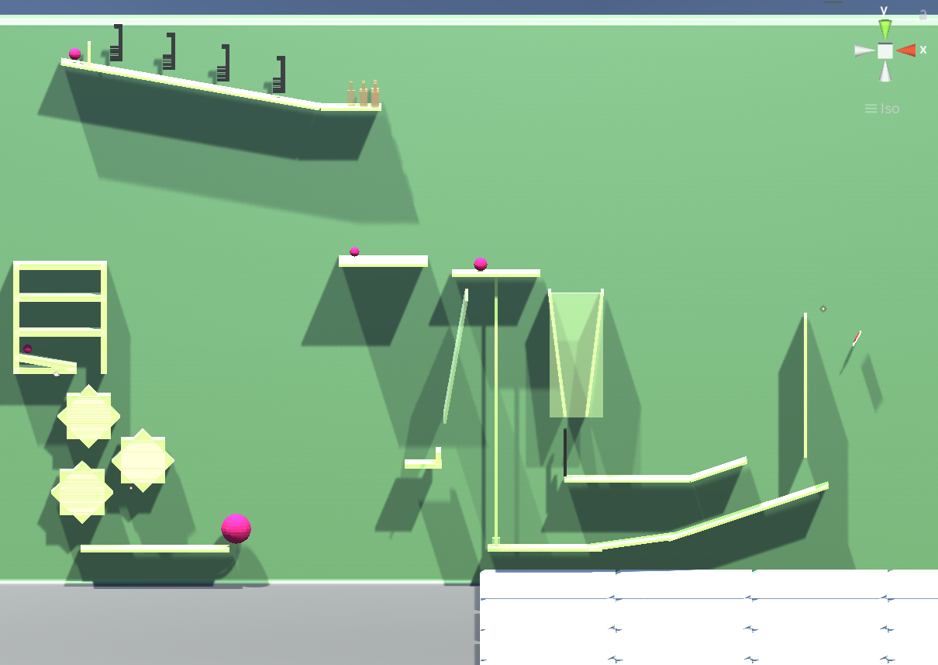

# Changelog/Diary

## 22/07/2024

* Assessment introduced in class
* Allocate group members
* Brainstorm potential ideas, concepts and goals

## 29/07/2024

* Created first model of duck for machine
* Created GitHub for collaboration
* Created discord for communication.
* Discussed machine ideas

## 5/08/2024

* Planned and finalised our sink model, bathroom model, toaster model, bath bomb model, and comb model, ready for it to be exported into unity.
* Started each section.

## 12/08/2024

* Planned and finalised our sink model, bathroom model, toaster model, bath bomb model, and comb model, ready for it to be exported into unity.
* Stand up meeting to check everyone progress.

## 19/08/2024

* We tested out all our sections together.
* Resolved any GitHub issues with merging our sections.
* Organised scaling.
* Completed all sections.

## 22/08/2024

* Merged updated final versions onto main file.
* Resolved any extra issues/concerns.
* Handed in Assignment 1.

Please see note below ->

**NOTE:** Section 2 (Liliana’s section) contained a more complex hinge seesaw which worked on her file however, it was unable to function when the files were all merged, as a result it became a ramp. However, a screen recording has been added to show her section fully functional.

Section 2 Screen Recording Link: <https://www.youtube.com/watch?v=OSfQzno_EIw>